# Faculty: How to View Accommodation Requests

1. Login to the [AIM Faculty Portal](https://hunter.accessiblelearning.com/Citadel/instructor).
2. Agree to the **Access Policy** by clicking the “**Continue to View Student Accommodations**”. 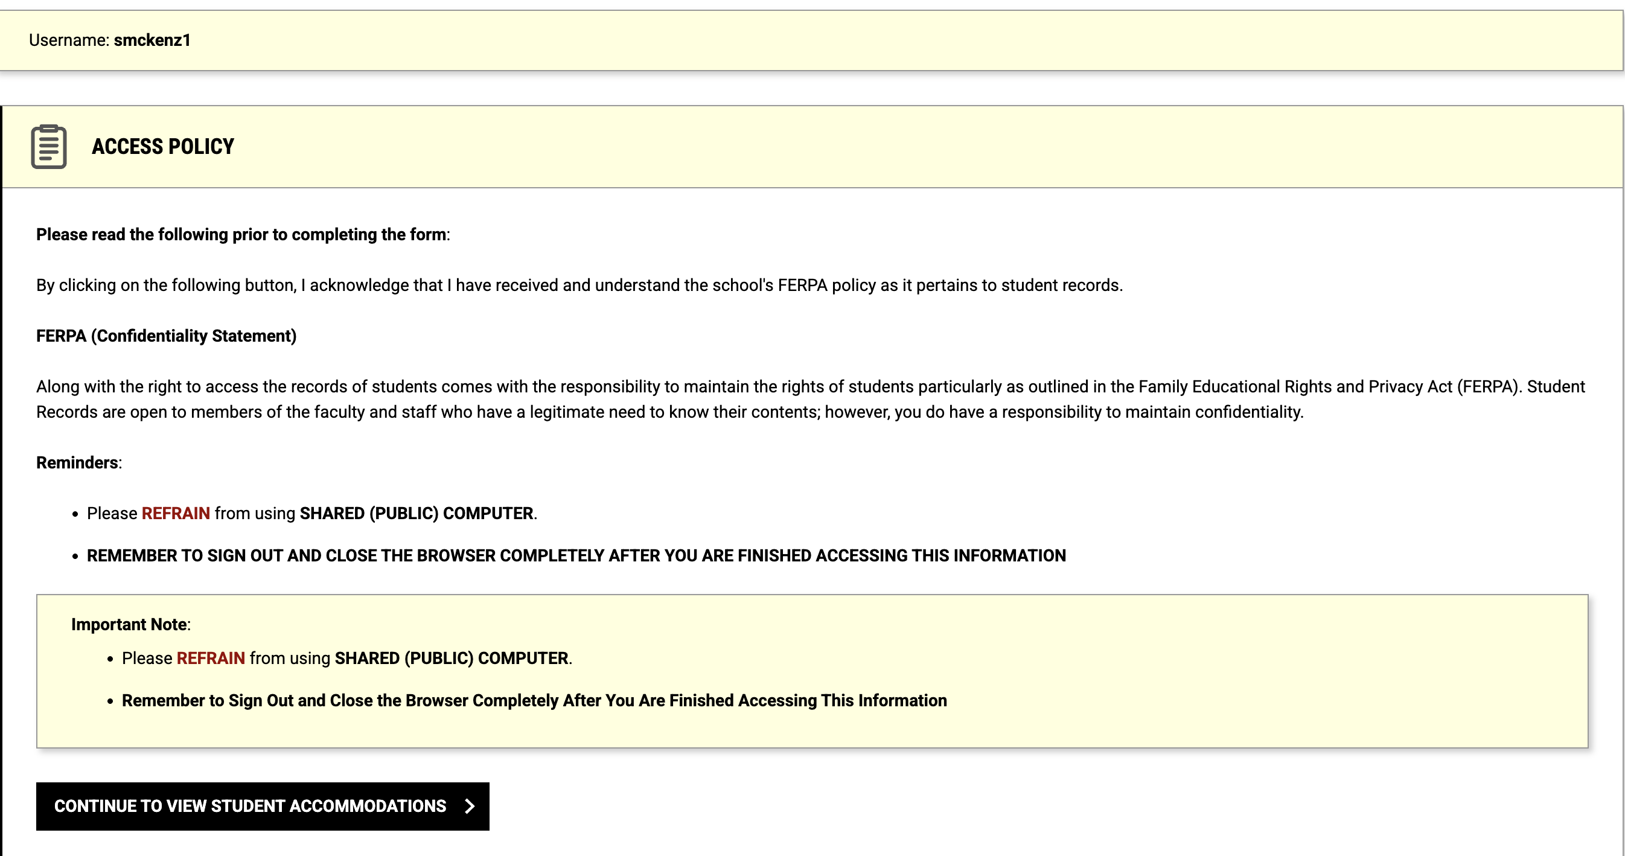
3. A student list will be at the bottom of the page. Click **VIEW** next to the student's name.

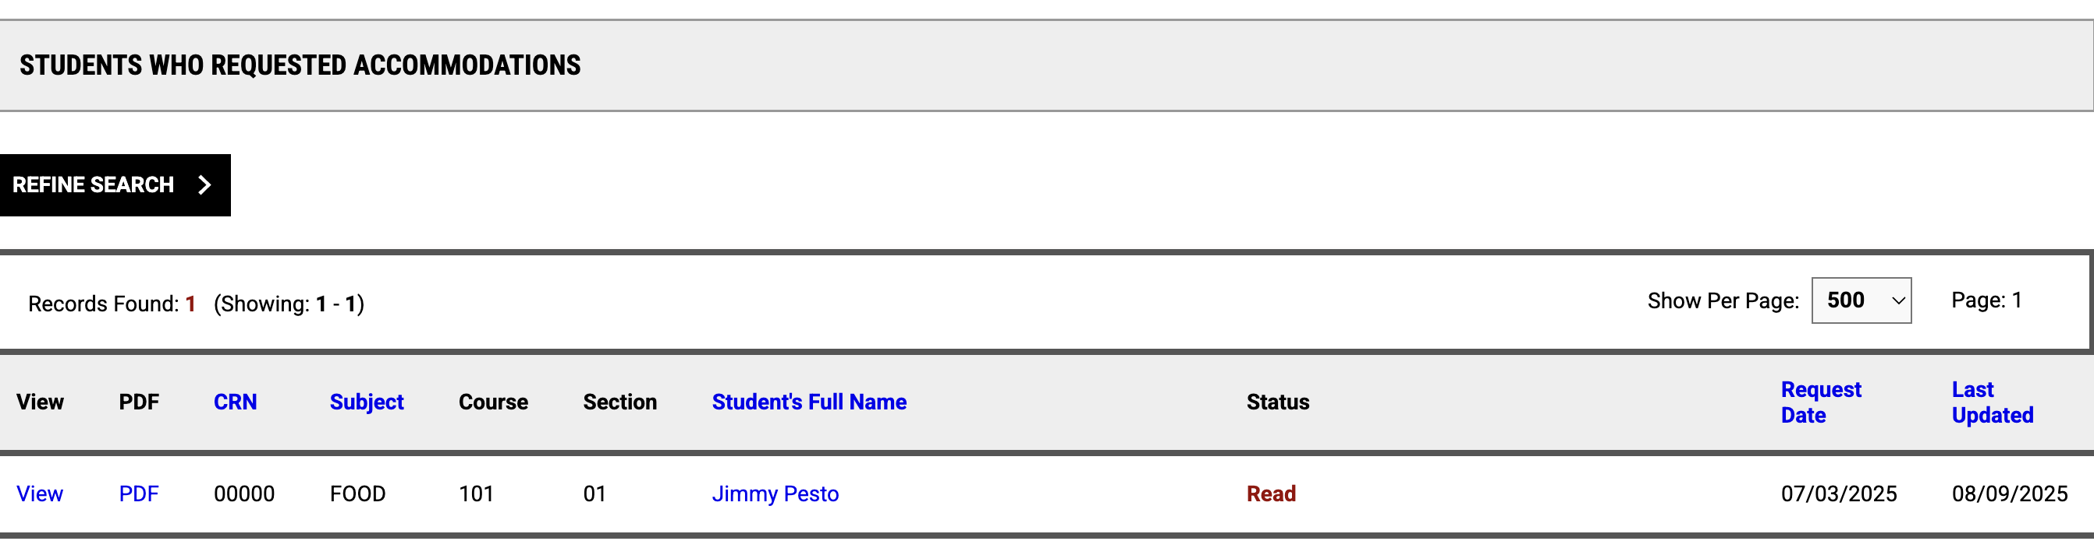

1. The next page will show the student's list of accommodations with descriptions.
2. If you have not communicated with the student, click on **Return to Previous Page**.
3. Once you have communicated (email, phone, in-person meeting, etc.) with the student about their accommodations, you can acknowledge it by clicking the **Submit Acknowledgement Electronically** button. 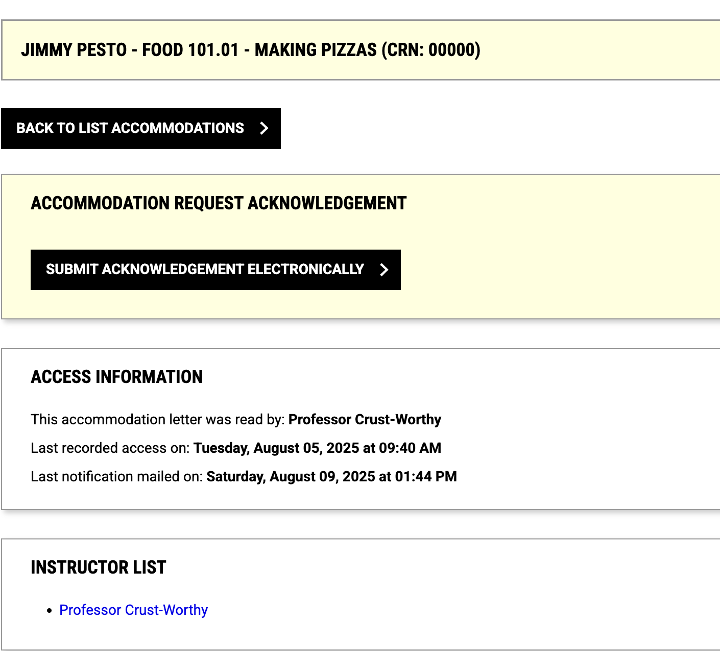
4. You will receive an email for your records, and the student status will be marked Acknowledged.