# Application Instructions

Instructions:

1. Go to my website here: <https://www.citadel.edu/ssc/disability-services/>
2. Scroll down the page until you see the Blue rectangle that says “Start The Application Now.” Click the button.

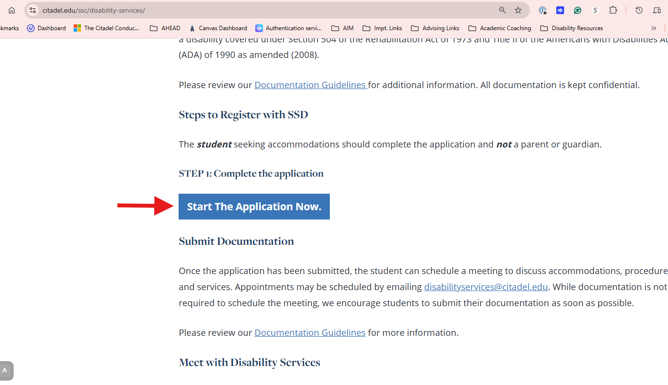

1. Fill out the online application. It will ask you information about yourself, contact info, major, etc. It will ask about your disability(s).
2. When you have filled out the required information, click on “Create Application Draft”  
   A screenshot of a application form

   
3. Next, Click on Questionnaire and answer those questions to the best of your ability.

A screenshot of a computer screen showing where to click for questionnaire


1. Save the Application. You can then upload your documentation to the application portal:

A screenshot of how to sane and upload documentation



1. Upload your file by choosing the file and then clicking, “Upload File” Once you have uploaded all the files you need to include, click: Proceed to Final Review”

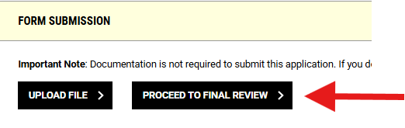

1. To Submit the application, you will need to read the agreement statement and click “Submit Application.”