# **Requesting Accommodation Letters**

Each semester, you can log into the [AIM Student Portal](https://hunter.accessiblelearning.com/Citadel/) to request accommodation letters to be created and sent out to your instructors. Please follow the steps below to request your accommodation letters.

1. **Log in to the AIM Student Portal**
2. **On the Overview screen, look for the current term and select “Add Requests”.**

A screenshot of a computer



1. **On the next screen, your courses will automatically populate.** If you have just registered for a course, please allow the system 24 hours to update your information. If you do not see your course listed, please contact us as soon as possible. To request your letter, select the course, then click the button labeled **“Continue to Next Step”**.

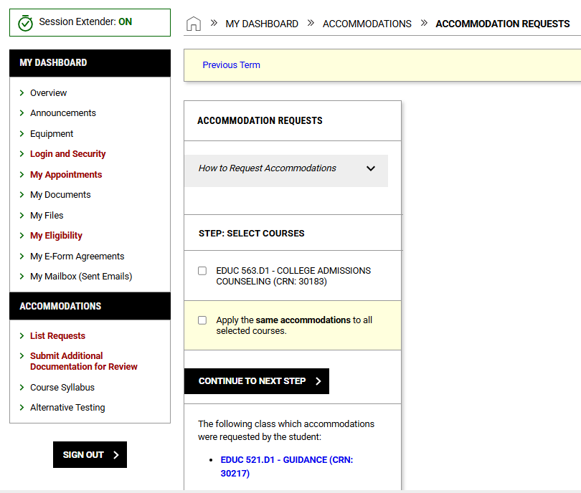**Additional Note:** If you would like to utilize the same accommodations to the courses you selected, press the “Apply same accommodations to selected courses”.

1. **On the next screen, check the box for specific accommodations that you would like included in your letters that will be sent to your faculty.** If you want to use all your accommodations in all of your classes, press the “Select All” check box.

A screenshot of how to select all accommodations for your classes.



1. **After confirming your selected accommodations, please review the final step which includes the “Terms and Conditions” regarding Accommodations**. After reviewing, select the checkbox and move down to select the **“Submit Request**” option.

A screenshot of final step and the submit button.



1. A white rectangular sign with black text and green check-mark
   **After you select “Submit Request,” your accommodation letters will be emailed to you and your instructors.**  You should see a green check notifying you that the request was submitted successfully. Some accommodation letters may require approval by our office. Accommodation letters requesting manual approval will be sent within one **business day** of the request.
2. To check the status of your request, select the “List Requests” Link under the Accommodations Section on the left-hand toolbar.

**A screenshot of the dashboard pointing to the List requests link


**

A screenshot of the portal showing the request status



**If you would like to download a PDF of your accommodation letter to print out, or if your faculty member requests you to provide a paper copy, follow the directions on the next page.**

**How to Download your Accommodation Letter as a PDF**

1. Click on “List Requests” on the left-hand side of your dashboard. You can find this under **“ACCOMMODATIONS”.**

**A screenshot of the student dashboard in AIM
**

1. You will see a list of accommodations that have been requested for your current and past semesters. Click the class you would like to generate as a PDF.

A screenshot of a computer screen showing a list of courses.



1. Now Click “Generate PDF” and save the file.

A screenshot of a screen where you generate a pdf.

