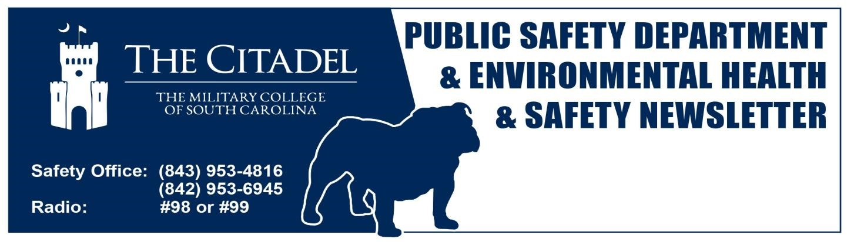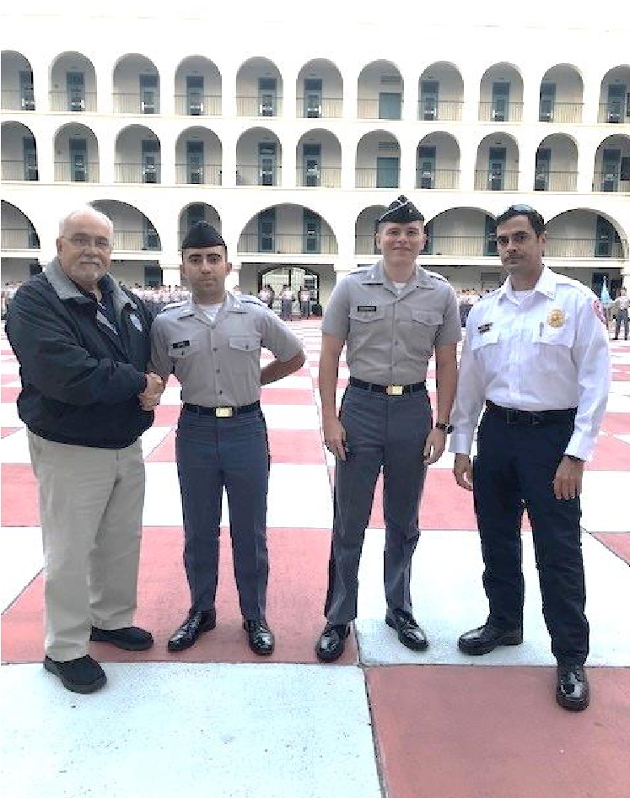
vi

777777777777777777777777777777777777777777777777777777777

Safety Counter

58

Days Since Last Recordable

Bastin Business

OSHA
08
.
2
4
.
2022

(
Laceration
-

sutures
)

First Aids
–

Laceration
–

Zone Maint.

9
/
12
/2022

October 21
,

2
022

Safety Office:

(843) 953
-
4816

(843) 953
-
6945

 |  | Safety Stats |  | Pictured left to right: David Orr, Director EHS, Cadet Kevin Lopez, Cadet Tristan Eberbach, and Jesse Soares, Campus Fire Marshal.  On Thursday 6 October at approximately 11:10 a.m. a fire broke out in a dryer at the Coin Laundry on campus. Due to the quick response of Cadet Lopez and Cadet Eberbach, the fire was quickly extinguished using the fire extinguisher that was in the Coin Laundry. Their teamwork and knowledge of what to do minimized what could have been a far worse situation.  Each Cadet was awarded an Environmental, Health, and Safety Challenge Coin, which is presented to those individuals who go above and beyond the call of duty in respect for safety on campus.  GREAT JOB CADETS!  s http://www.citadel.edu/root/safety-alerts  http://www.citadel.edu/root/citadel-safety-newsletters itadel.edu/root/images/environmental_health-safety/campus-aed-map.pdf
 |  | 4 | YTD Campus Recordable Injuries
 |  | 3.6 | RIR Rate (Target: 0.00)
 |  | 8 | YTD First Aids & Report Only
 |  | 1.9 | NCAIS Educational Institution Avg.
 |  | Days Since Last OSHA Recordable
 |  | 2,182 | Zone Maintenance
 |  | 623 | HVAC
 |  | 574 | Grounds
 |  | 1,856 | Machine/Plumbing Shop
 |  | 1,051 | Electrical Shop
 |  | >1,200 | Motor Pool
 |  | 58 | All Other Campus Departments
Link to Safety Alert
Link to Safety Newsletters
Campus AED Locations: http://www.c
 | Upcoming Events Provided  Through EHS  The following events offered through the EHS department. Continue to monitor the EHS Newsletter and correspondence from the department.  - First Aid, CPR, AED training – UPDATE: We now have three certified First Aid/CPR/AED instructors on Campus. Contact the EHS offices to schedule a class. This class will allow a two-year certification through The American Red Cross. (As of 10/21/2022 – over 160 individuals trained.) Soon will be training on BLS (Basic Life Support First Aid Classes) and Stop the Bleed.  - Defensive Driving Classes – Anyone who utilizes a Citadel vehicle needs to attend a defensive driver course through the National Safety Council. This training is provided through the EHS department. Stay tuned for spring classes to be scheduled soon.  (Certificate Class 3-year cycle)  - SAFETY DAYS – The EHS Director and campus Fire Marshal are in the process of developing continued and makeup sessions for EHS/Life Safety training. This training will provide required regulatory training along with fire extinguisher training utilizing the school’s fire extinguisher simulator. (Certificate of Completion)  For more information, you can contact the EHS Department or Campus Fire Marshal at (843) 953-4816, (843) 953-6945. Email: horr@citadel.edu or jsoares1@citadel.edu |  |  |  | 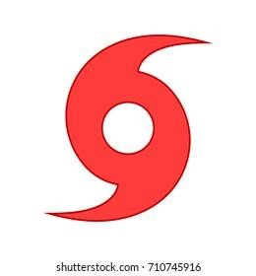  Hurricane Season 2022  June 1  ^{st}  .  to November 30  ^{th}  .  We are past the peak of Hurricane Season (Sept  10)  and on the downhill side, but still have  4  0  days until the end of the 2022 Hurricane Season.  So far in 2022, we have seen 11 name  d  storms  compared to 21 named  storms in 2021  and  30  named storms in 2020 (most in recorded  history).  NOW IS A GOOD TIME TO REVIEW  WHAT  OCCURRED IN 2022  AND UPDATE YOUR  RESPECTIVE DEPARTMENTAL HURRICANE  RESPONSE PLANS  ACCORDINGLY.  2022  Hurricane Names  Alex  Ian  Richard  Bonnie  Julia  Shary  Colin  Karl  Tobias  Danielle  Lisa  Virginie  Earl  Martin  Walter  Fiona  Nicole  Gaston  Owen  Hermine  Paula

SAFETY PICTURE OF THE DAY
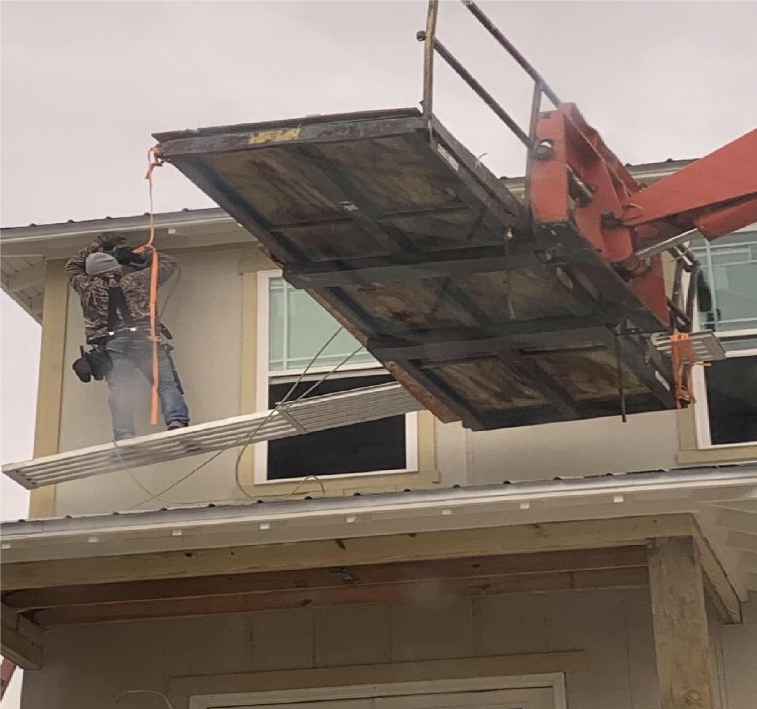

WHO CAN TELL US WHAT IS WRONG WITH THIS PICTURE?

WHAT TO DO IN CASE OF FIRE OR EMERGENCY IN A CAMPUS BUILDING

. Numbers to call in case of a fire or emergency:

A. From a campus (VOIP) phone | B. From a cell phone
- 953-5114 (Citadel Public Safety) | -911 (Charleston 911 Dispatch Center)
-811 (Citadel Public Safety)  2. Give the following information: | -843-953-5114 (Citadel Public Safety)
A. Name | D. Nature of emergency (What is the situation?)
B. Phone Number (Preferably a cell #) | E. Number of Injured
C. Location (Bldg, Room #) | F. Nature of Injuries (How/what is injured?)

DO NOT hang up until told to do so.

- ALL PERSONNEL MUST EVACUATE the building when a fire alarm is sounding. NO EXCEPTIONS!

- Know multiple routes out of your building. DO NOT use an elevator in the event of a fire or emergency.

- Know where your fire extinguishers are located and what types of extinguishers are available.

- Only attempt to extinguish a fire if you deem it safe enough and small enough. If in doubt, evacuate.

- Know where the closest fire alarm pull station is located. Most are located near an exit or door to a stairwell.

- Consider your co-workers. Provide additional help evacuating to those in need, i.e. injured, handicapped, and elderly.

- Know where your muster points are located. All facilities should have a primary and alternate muster point to assemble and complete accountability of all faculty, staff and students. Muster points should be far enough away from the building to avoid impeding emergency response vehicles. Primary and alternate muster points should be located away from each other in case one is impacted by smoke, gases, etc.

- Notify emergency responders of anyone that may still be left in the building and where they may be located.

- DO NOT RE-ENTER THE BUILDING for any reason. Only re-enter the building after being given the “ALL CLEAR” by Public Safety and alarms have been silenced.

- Close all doors in office, administrative and educational buildings after rooms have been evacuated. This is especially important if the room is on fire. Closed doors will help to compartmentalize the building and reduce the spread of fire.

- Barracks doors will be left open with lights on after evacuation unless the room in question is on fire. That door will be closed. Barracks doors left open are to help assist in the evacuation and accountability process.
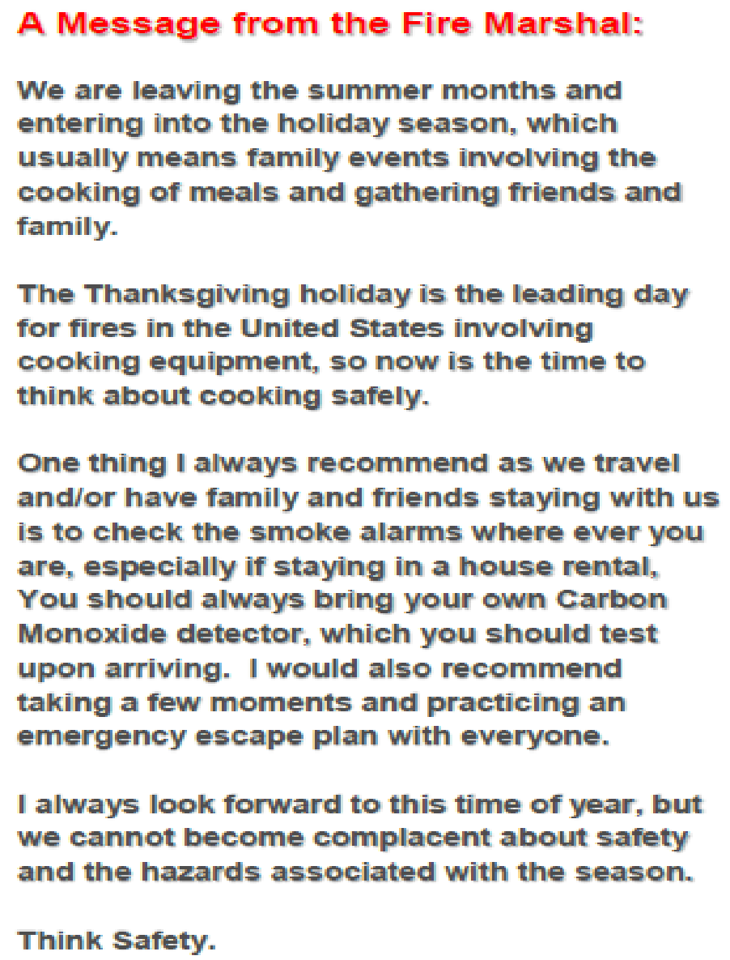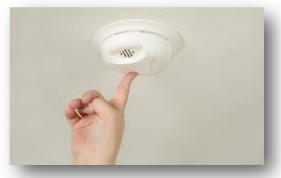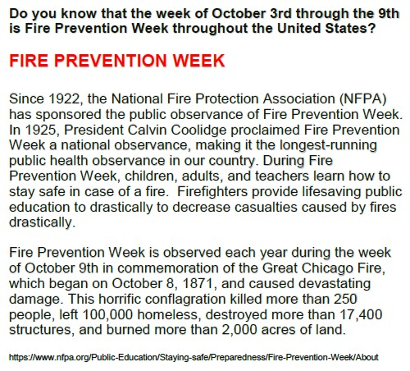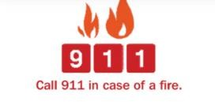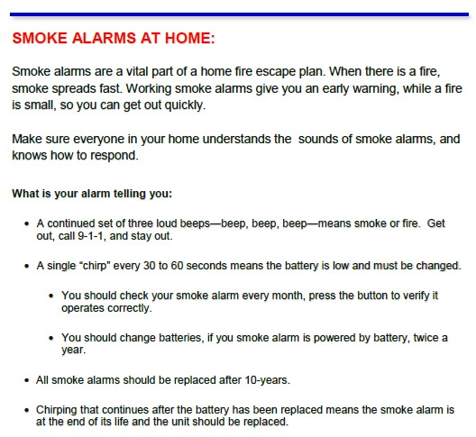

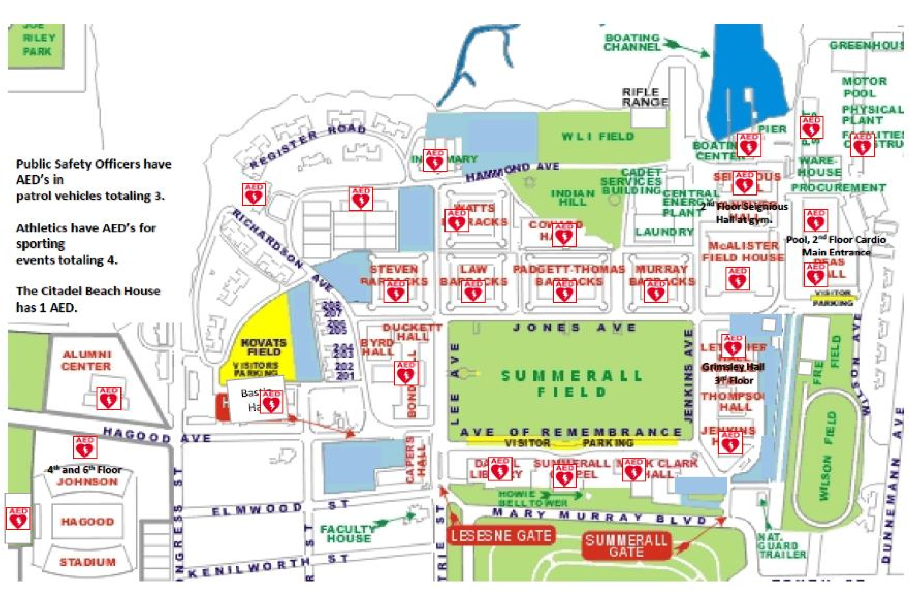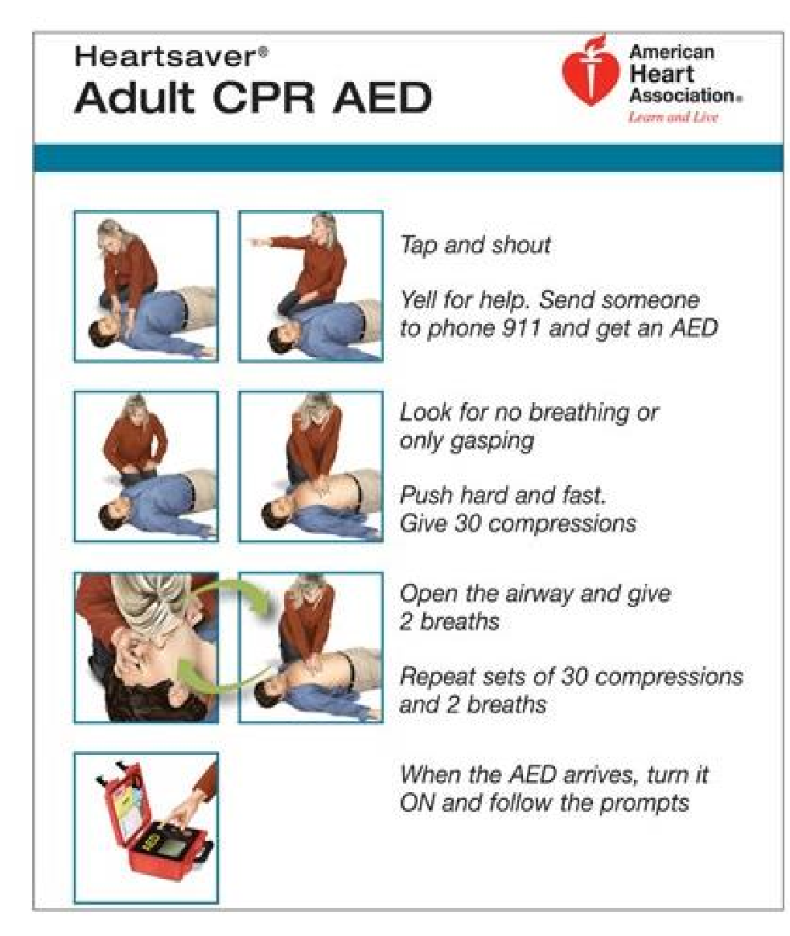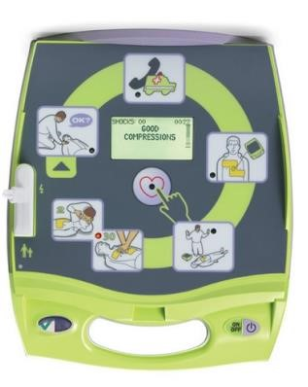

Ask a Safety Professional

This month’s column questions to the Environmental Health and Safety Newsletter are featured below:

- What are the 7 elements of Safety?
  - Safety Culture
  - Employee Training and Empowerment
  - Hazard Identification and Control
Systems
  - Focus on Compliance
  - Continuous Improvement
  - Leadership and Organizational Buy-In
  - Safety Management’s Role

- What types of hazards potentially exist in the workplace?
  - Safety Hazards
  - Biological Hazards
  - Physical Hazards
  - Ergonomic Hazards
  - Chemical Hazards
  - Workload Hazards

All of these hazards exist here at the Citadel and employee recognition is extremely important.
- Hazard – is any source of potential damage, harm or adverse effects on something or someone under certain condition.
- Identification – hazard identification is the systematic observation of unsafe conditions, negative behaviors and weaknesses within the management structure that could lead to injuries and illnesses.

Anyone can ask an Environmental, Health, Safety or Life Safety question by submitting it to either Dave Orr at horr@citadel.edu or Jesse Soares, Campus Fire Marshal at jsoares1@citadel.edu

Have a Safety and Healthy Day
Corny Joke of the Month:

Where do boats go when they are sick……….?

THE DOCK!

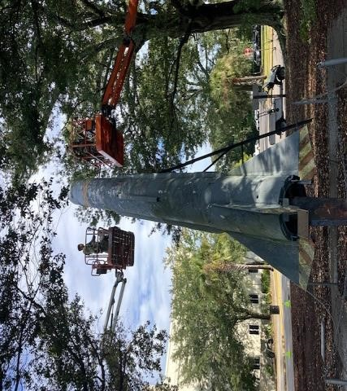
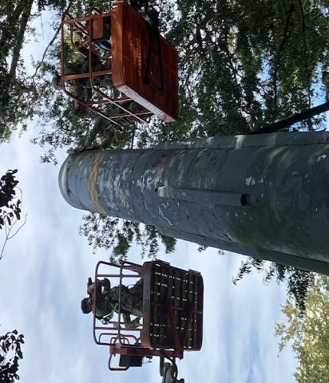
y

X
-
raying the missile on Summerall Field
to determine
whether
anything internal to
the missile was inert
or if the
device

was
empty.
Good news
–

missile was empty
and cleared for disposal by the Army
EOD Team.

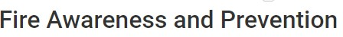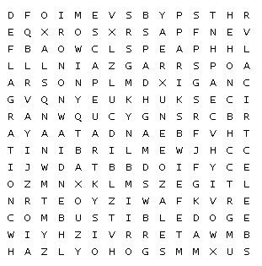

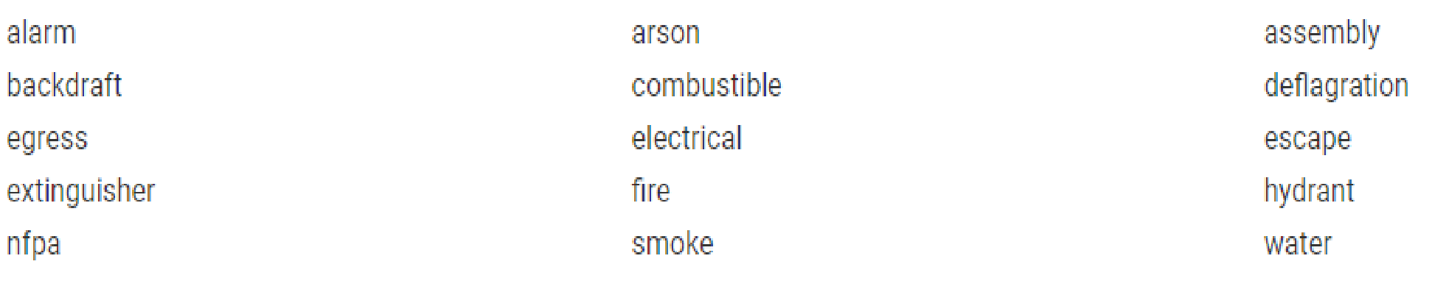

THERE HAVE BEEN SOME CONCERNS RELATED TO LOCKOUT/TAGOUT SO WE ARE RUNNING THIS ARTICLE AGAIN THIS MONTH!

THE IMPORTANCE OF LOCKOUT/TAGOUT
(OSHA 29CFR1910.147)

Lockout Tag out Hazards:
  - Lockout/Tag out saves lives and can help save YOUR life.
  - Every year, many workers are killed when the equipment they are working on is accidentally started up or energized. Workers lucky enough to survive have reported they never expected a coworker or other person to energize the circuit, open a valve, or attempt to operate the equipment.
  - All sources of “energy” must be isolated or “removed” before any workers is allowed to repair, maintain, adjust, or setup a piece of equipment or process that has potentially dangerous sources of energy – this can include stored energy.
  - Energy can include electrical, air pressure, hydraulic pressure, steam, gravity, or mechanical energy found in springs.
  - Even when the equipment is shutoff, some machinery and equipment has “stored” energy such as the pressure that remains in a hydraulic line or cylinder or the electrical energy that remains in a capacitor even when the source of power has been shutoff.

Protect Yourself:
  - Learn and understand the sources of energy in the environment.
  - Remove or “isolate” the equipment or system from ALL sources of energy and operation.
  - Carefully remove or “bleed” stored energy from the equipment or system being serviced.
  - Place a lock and tag on each control used to isolate energy from the equipment or process. Always use lockout/tag out…. even if what you must do will only take a minute. It only takes a second or two to get injured or worse!
  - Attempt to start or operate the equipment or system AFTER you have shut off and removed stored energy from the equipment or process.
  - Always remove the lock and tag from all sources of energy when you have finished. Not removing locks and tags when complete may cause others to lose respect for the lockout/tag out program.
NEVER REMOVE ANYONE ELSE’S LOCK AND NEVER WORK UNDER SOMEONE ELSE’S LOCKOUT. ONE LOCK, ONE TAG AND ONE PERSON.

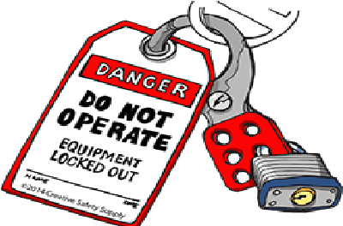
Source: The Horton Group, Safety Boss Tip 13

