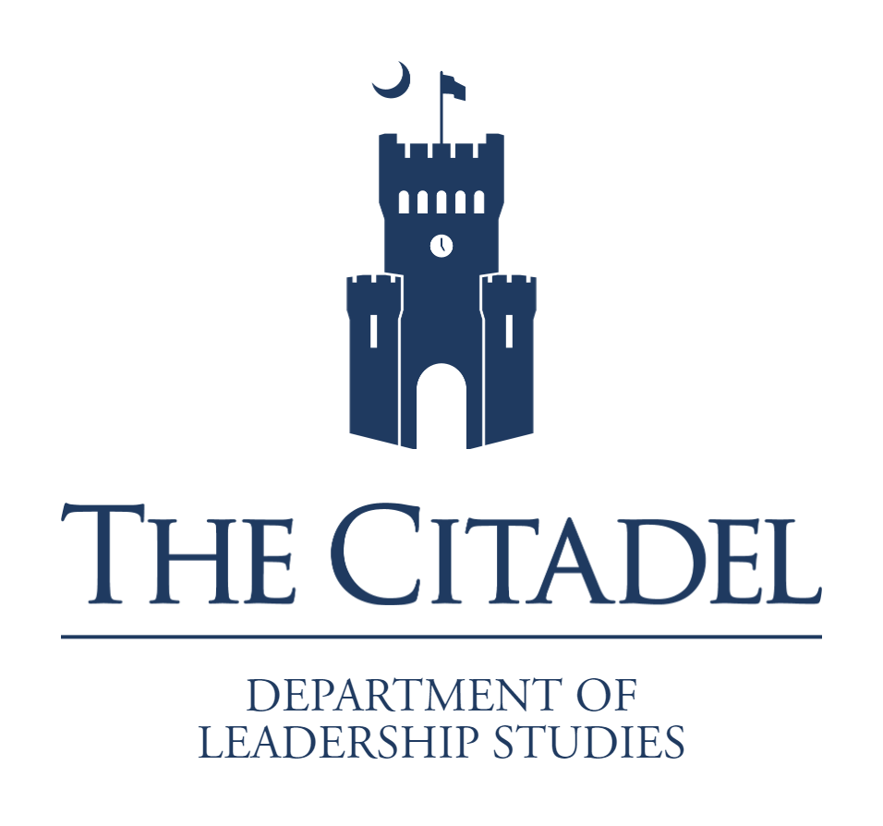

Fall 2024 ROTC Fulfillment Advising Packet

FALL 2024 ROTC FULFILLMENT

ROTC Fulfillment Registration Information
- All upper-level (1B-2A) cadets (both contracted and non-contracted) are required to enroll in
LDRS 371
- Contracted cadets are not required to enroll in any additional ROTC fulfillment courses (note: LDRS 371 is used as a ROTC fulfillment course)
*If you have questions about your degree map, please contact your advisor and Leadership Studies.

One ROTC Fulfillment Course Each Semester
- Upper-level (1B-2A) cadets meet the ROTC Fulfillment requirement by taking approved leadership minor and/or high-impact practice courses each semester
- Noncontract upper-level (1B-2A) students must
pass one ROTC Fulfillment course each semester.
- Students will receive credit towards their ROTC Fulfillment requirement for one ROTC Fulfillment course each semester, regardless of how many they successfully complete each semester. (note: LDRS 371 is used as a ROTC fulfillment course)

No ROTC Fulfillment
- Students under military contract are not
required to take ROTC Fulfillment courses
- Krause Center experiences do not fulfill the ROTC requirement. (LDRS 211, 311, and 411 non-credit bearing experiences)

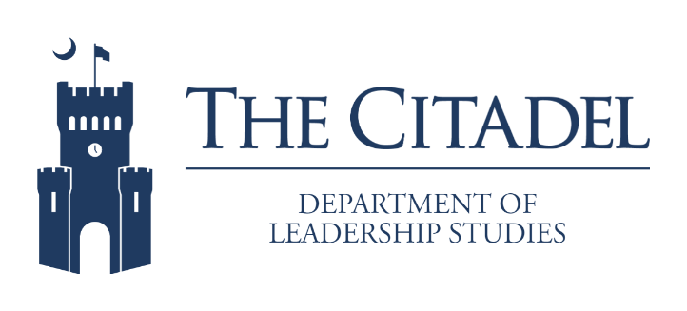
LEADERSHIP MINOR COURSES

- LDRS 371
- Leadership in Organizations
- EDUC 330
- Developing Leadership Skills Through Peer Counseling
- INTL 402
  - Military Instrument of Power
- MGMT 303
- Human Resource Management
- MGMT 311
- Human Resource Management
- MGMT 411
- Business Ethics
- PHIL 290
- Ethics
- PMGT 401
- Project Management Career Skills
- PSCI 306
  - Legislative Process
- SMGT 302
- Sport Communications
- SMGT 404
- Leadership in Sport Organizations

CONTACT US
The Citadel
Department of Leadership Studies Bond Hall Suite 364
(843)953-8401
leadership@citadel.edu
ROTC Fulfillment Program WebpagE
2
2024 ROTC FULFILLMENT
COURSES & SCHEDULE
- ACCT 460
  - Internship: Accounting
- BIOL 320-324
  - Undergraduate Research in Biology
- CHEM 419
  - Senior Research I
- CIVL 432
  - CE Design Capstone I
- COMM 499
  - Internship: Communications
- CONE 302
  - Engineering Law Ethics &
Safety Control
- CONE 440
  - Construction Method & Structural Design
- CONE 481
  - Constr Eng Senior Design I
- CRMJ 311
  - Human Trafficking
- CRMJ 332
  - Comparative Counter-Terrorism
- CRMJ 390
  - Victimology
- CRMJ 422
  - Capstone
- CRMJ 465
- Law of Armed Conflict
- CSCI 491
  - Internship: Computer Science
- CSCI 495
  - Senior Seminar
- ECON 460
  - Internship: Economics
- EDUC 202
  - Educational Psychology
- EDUC 206
  - Adolescent Development
- EDUC 306
  - Teaching Reading & Writing
- EDUC 312
  - Learners with Exceptionalities
- EDUC 330
  - Developing Leadership Skills Through Peer Counseling
- EDUC 402
  - Special Methods in Teaching

- EDUC 499
  - Internship: Teaching
- ELES 303
  - Immersive Cultural Experience
- ENTR 401
  - Small Business Mgt/Entr
- Experiential Fine Arts Classes
- FNAR 304
- FNAR 305
- FNAR 306
- FNAR 307
- FNAR 309
- FNAR 350
- EXSC 406
  - Directed Field Experience
- FINC 460
  - Internship: Finance
- GERM 450
  - Special Topics
- HIST 371
  - Historical Stud. Leadshp
- HIST 446
  - Capstone
- HIST 498
  - Internship: History
- HLED 400
  - First Aid, Emerg Care
- HONR 400
- Research Project
- INTL 301
  - Advanced Analytics
- INTL 402
  - Military Inst. of Power
- INTL 464
  - Internship: Intel
- LDRS 371
- Leadership in Orgs
- LDRS 401
- Research Seminar
- MATH 495
  - Senior Seminar in Mathematics
- MECH 481
  - Senior Design I
- MGMT 301
  - Principals of Management

- MGMT 303
  - Organizational Behavior

- MGMT 311
  - Human Resource Management
- MGMT 411
  - Business Ethics
- MGMT 449
- Strategic Management
- MGMT 460
  - Internship: Business
- MKTG 460
  - Internship: Marketing
- NURS 311
  - Clinical Experience: Nursing
- NURS 411
  - Clinical Experience Nursing
- PHIL 290
  - Ethics
- PHYS 420
  - Physics Capstone
- PMGT 401
  - Project Management Career Skills
- PSCI 306
Legislative Process
- PSCI 393
Research Methods
- PSCI 403
  - Pol Geo 24 Election
- PSCI 499
  - Internship: PSCI
- PSCY 410
  - Capstone
- SCMT 460
  - Internship: Supply Chain Management
- SMGT 302
  - Sport Communications
- SMGT 404
  - Leadership in Sport Org
- SMGT 499
  - Internship: Sports Management
- SPAN 460
  - Internship: Hispanic
3
Language & Culture

