
CSI 2026 PACKING LIST
ALL clothing must be conservative in style and length, fingertip rule applies.

CLOTHING:
5 CSI T-shirts provided upon arrival.
5 khaki shorts (with belt loops, past finger-length)
8+ sets of underwear (sports bras recommended)
5+ pairs of White 2-inch ankle socks
2 pairs of running shoes (navy or black)
1 conservative belt (black or brown)
1 black or navy rain jacket or poncho (available for purchase at the Cadet Store)
2 pajama sets (appropriate for evening fire drills)
1 pair of shower shoes (rubber flip flop)
3 outfits of civilian clothes for off campus, weekend use
1 bathrobe (neutral color, plain design; loaner items are available to all students)
Optional: 1 pair black low-quarter shoes with 3 pairs of black cotton crew socks (see Pg2)

PHYSICAL FITNESS TRAINING (PT):
2 standard issue Citadel PT uniforms are provided with an additional charge (it is recommended to purchase additional uniforms at the Cadet Store)
1 Bathing Suit (solid black or navy blue; female - conservative one piece)
Black compression shorts required if PT clothing is too short or not conservative

ROOMS ITEMS:
Laundry detergent
Paper towels, Clorox wipes, Air freshener (optional)
Combination lock
Optional: Oscillating fan (can be shipped to student after arrival)
LINENS:
2 Cotton bath towels, 4+ washcloths, 1 beach-appropriate towel
1 Pillow and a white pillowcase (standard size)
2 non-fitted extra-long twin sheets (white, plain)
1-2 blankets or thin bedspread (twin size, neutral/plain)

PERSONAL ITEMS:
Money/forms of payment
1 liter water bottle (label with name)
Sunscreen
Insect repellant
Shower caddy
2 MS 3WH mesh laundry bags 24”x36” with name tags (available for purchase at the Cadet Store)
Small first aid kit
Cellphones, chargers for ALL electronics, and headphones
Toiletries: toothbrush, toothpaste, deodorant, bodywash, razor, shaving cream (for males being clean shaven daily is a dress code requirement)
Females: 5 hair ties (must match hair color) & additional items to keep hair in a bun

ACADEMIC ITEMS:
1 Laptop bag with handles (free supply of limited loaner items available to early registrants)
1 Laptop
1 Graphing calculator (if taking a math course)
Basic school supplies (spiral notebooks, pens, pencils, highlighters, 3 X 5 index cards, folders with pockets)

WHAT NOT TO BRING:
Posters or wall hangings; Television, refrigerator, or kitchen appliances; Electronic games or consoles, extension cords without a surge protector, external speakers; Expensive/excessive jewelry not allowed under the dress code; alcohol, tobacco products, illegal substances, or paraphernalia

RECOMMENDATIONS:

COMPUTER BAG WITH HANDLES  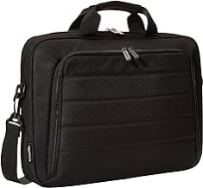 | 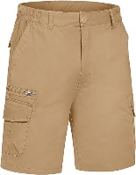  BELTED KHAKI SHORTS | 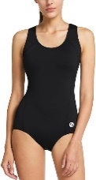  WOMEN’S SWIMWEAR  BLACK CREW SOCKS | 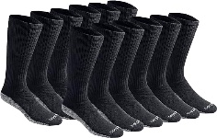

MILITARY STYLE DRESS SHOES:
Invest in one pair of black low-quarter shoes and break them in during CSI (2 pairs are required for Matriculation so breaking in one pair at CSI is recommended). The dress shoes should meet the following specifications:
- Black Oxford.
- Plain Toe
- Plain Heel (no additional stitching on the sides from the toe to the back of the shoe - see photo below)
- Smooth Leather
- Rubber Heel and Sole
- High gloss, poromeric, or coframe shoes are not authorized for wear.

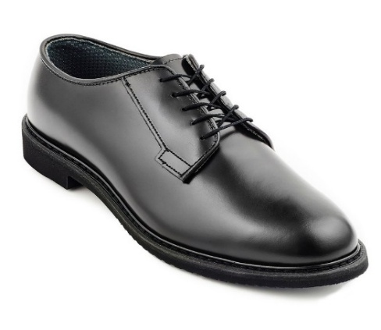
Before ordering your shoes online, get your feet measured at a reputable shoe store. You can find various manufacturers of this type of shoe online, at military exchanges, and shoe stores that service police departments. We also carry the Altama Mil-Spec Oxford 629001 (Men’s) and 629011 (Women’s) at the Cadet Store on campus. The Cadet Store has partnered with Read’s Uniforms to order this shoe online. CLICK HERE FOR INSTRUCTIONS.
IF YOU CHOOSE A DIFFERENT BRAND, ENSURE THAT IT MATCHES THE STITCHING SHOWN HERE.
NOTE: THERE IS NO STITCHING ON THE BACK SIDE BELOW THE ANKLE, MIDDLE OR ON THE TOE OF THE SHOE.

Freshman may hear that Florsheim’s Lexington Plain Toe Oxford is easier to shine, but we do not recommend this shoe because it’s not a military-style shoe and wears out quickly. If you choose this shoe, wear it only for inspections and wear military dress shoes otherwise. Once you get your shoes, break them in to avoid blisters during the first weeks of training.

