**To log into Joomla   
Note:** Joomla works best in Chrome or FireFox

1. Go to <http://www.citadel.edu/root/administrator/>
2. You are now viewing your Control Panel

**To edit an article or webpage**

1. On the Control Panel or Dashboard page, click drop-down arrow next to **Quick Menu and Article Finder** (located on right, last item in drop list). It will show a list of all the articles you have access to. Click a category to start editing those articles. Proceed to #4 below.

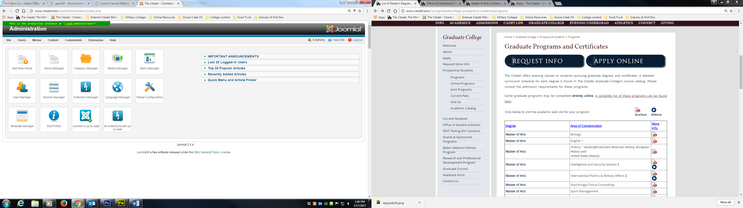

**Or**

1. In the top menu, go to Content> Article Manager.
2. In the Filter section, where it says “Select Category” scroll to find the department/website name (Remember this is not in ABC order so you will have to look closely).
3. 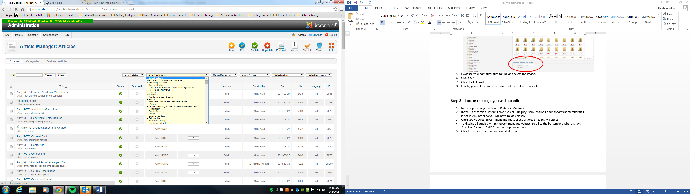
4. Once you’ve selected the department/website name, most of the articles or pages will appear.
5. To display all articles within the department/website, scroll to the bottom and where it says “Display #” choose “All” from the drop-down menu.
6. Click the article title that you would like to edit or select “New” to create a new article.
7. The Edit window will open to begin editing or adding content.

**Note:** If the article has a lock next to it, the article will need to be “Check in” in order to edit. Hover over the lock to see the date and time the article was checked-in. If no one is currently working on it, proceed to checking it in. To Check In, select the box next to the article, then click the Check In icon in the right tool bar.

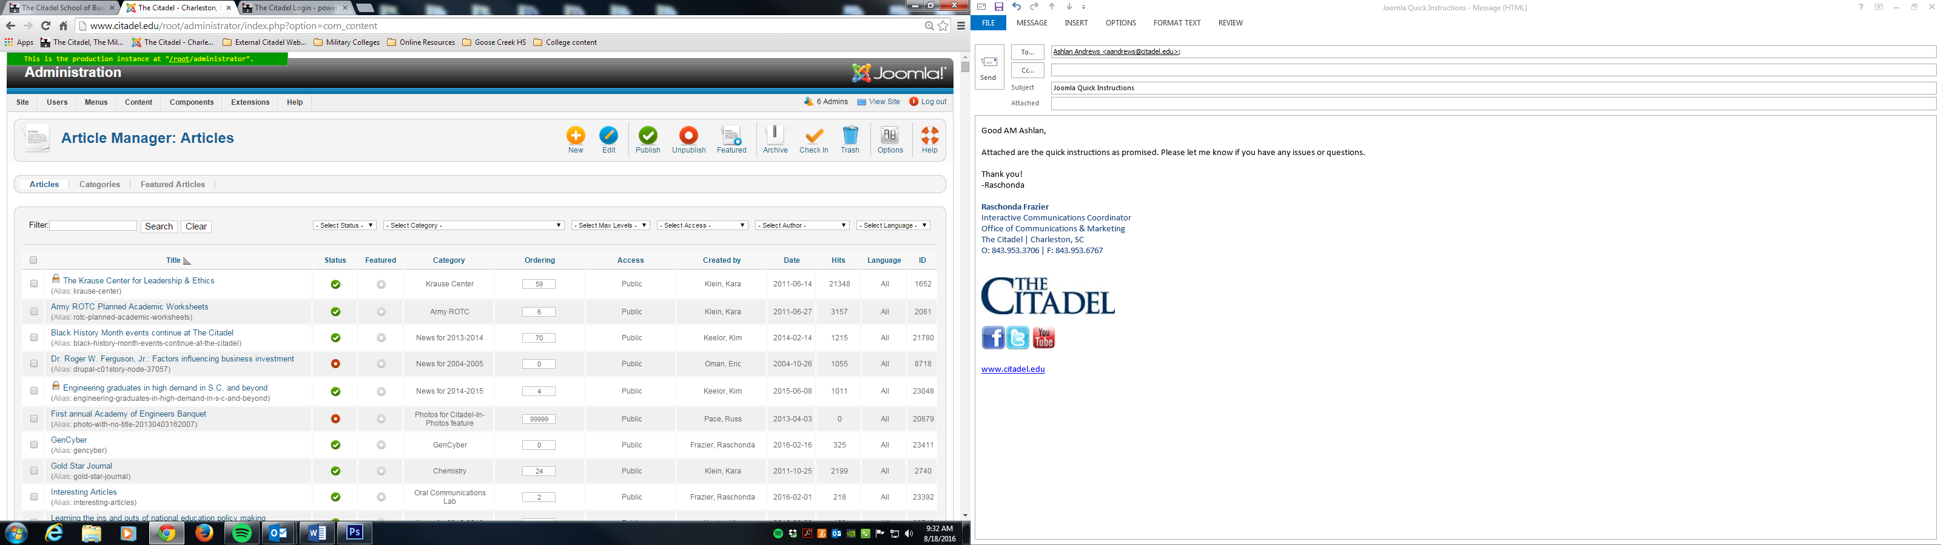

**To link a document or insert an image into an article, you must first, upload document(s) or image(s) to Media Manager** (skip to the next section if you are not uploading a doc or image).

1. Select Media Manager from your Control Panel or in the top menu, go to Content>Media Manager.
2. Locate and click the Department Folder
3. Scroll to the top of the page to “Files” box, which will be displaying all folders and files located in the Department Folder.
4. Under “Upload Files,” select Choose Files.

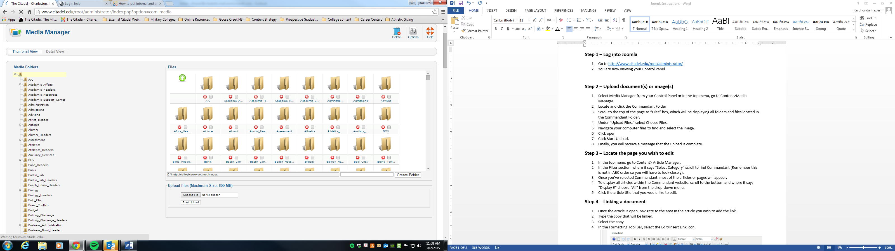

1. Navigate your computer files to find and select the image.
2. Click open
3. Click Start Upload.
4. Finally, you will receive a message that the upload is complete.

**To insert an image**

1. Open the article where the image is to be inserted.
2. Navigate to the area in the article you wish to insert the image.
3. In the Formatting Tool Bar, select the Edit/Insert Image icon  
   **Note:** You can hover over any icon in the Formatting Tool Bar to see what it is.

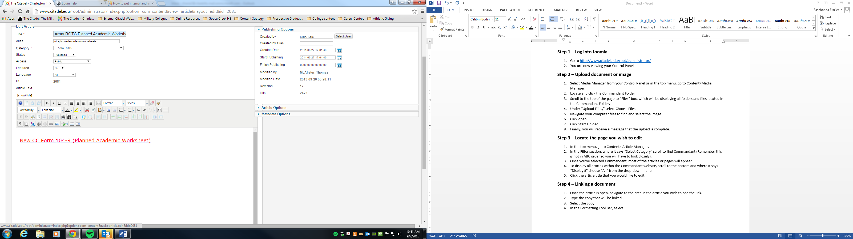

1. The Image Manager will open.
2. In the Folders section, locate and click the the department/website Folder
3. In the middle column, find and select the image.
4. You can then resize, align, add margins or a border but it is optional.
5. Select Insert
6. If you notice the image is too big, select the photo again, then click the Edit/Insert Image icon to edit.

**To link to a document (pdf, doc, xls, ppt) or image   
Note:** Skip to the next section for directions on how to link to another webpage or external website.

1. Once the article is open, navigate to the area in the article you wish to add the link.
2. Either type the text to be linked or highlight the text/image to be linked.
3. In the Formatting Tool Bar, select the Edit/Insert Link icon (see image)



1. The Link Manager will open.
2. Locate the Browser icon next to the URL field, then select it.
3. In the Folders section, locate and click the department/website Folder
4. In the middle column, find and select the document.
5. Select Insert
6. You will be returned to the Link Manager.
7. If you are linking to a third party website, then go to the Attributes section where it states “Target,” select Open in New Window from the drop-down menu.
8. Select Insert
9. Click off the highlighted or selected text.
10. If it linked properly, it should be blue and underlined.
11. Scroll to the top of the page, select Save & Close.
12. Finally, got to the webpage to review the changes.

**To link to another Citadel webpage or external webpage**

1. Once the article is open, navigate to the area in the article you wish to add the link.
2. Either type the text to be linked or highlight the text/image to be linked.
3. In the Formatting Tool Bar, select the Edit/Insert Link icon (see image).  
   **Note:** As a shortcut, you can right click to select the Edit/Insert Link icon.
4. The Link Manager will open.
5. Locate the URL field, copy & paste citadel or external URL
6. If you are linking to a third party website, then go to the Attributes section where it states “Target,” select Open in New Window from the drop-down menu.
7. Select Insert
8. Click off the highlighted or selected text.
9. If it linked properly, it should be blue (sometimes purple) and underlined.
10. Scroll to the top of the page, select Save & Close.
11. Finally, got to the webpage to review the changes.